BDSH Zen map (Nmap GUI) Report – Example network.

This is an example report for a network analysis from a team member of BDSH and does not include any AI analysis.
Contents
Summary report 1
General information 1
Description of the network 2
Figure #1 Network topology 2
Vulnerabilities 2
Pair with WireShark for further analysis? 3

Summary report
This network contains a series of 50 hosts on the network which includes 19 linux based operating systems and 3 windows-based systems, the rest are potentially IOT devices as they are running lightweight programs for operating systems.

General information
Started intense scan all TCP ports at 17:13, finished scanning the network 737.99 seconds/12 minutes later.
Hosts up: 50
Hosts down: 206
Hosts scanned: 256
Open Ports: 159
Filtered Ports: 8139
Closed Ports: 41702

Description of the network
The network that has been scanned is a rather large network for a personal home network and consists of one router, four wireless access points as well as 11 hosts with some filtered ports.
There are 19 Linux based operating systems operating on this network and 3 windows based operating systems.

Figure #1 Network topology
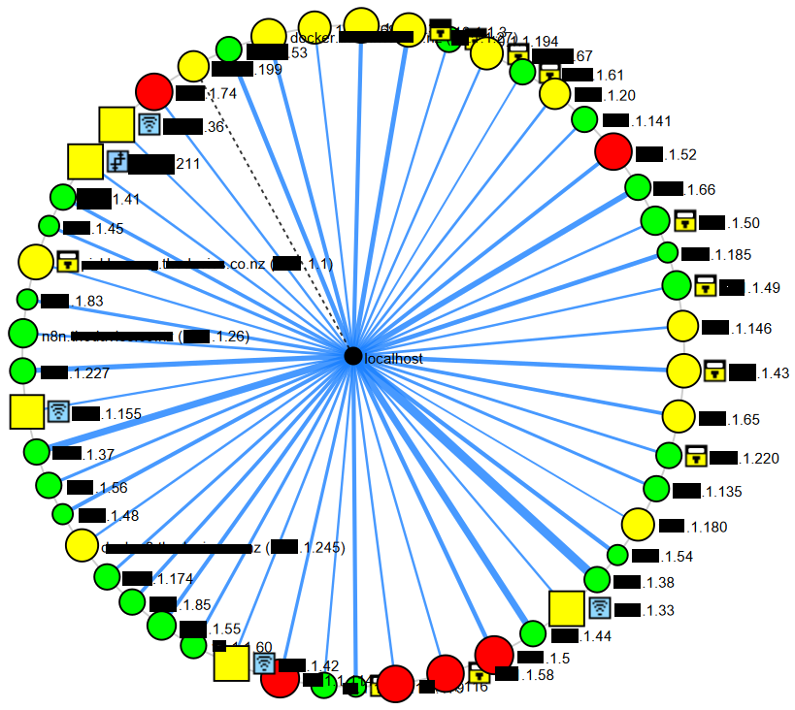

Vulnerabilities
For this section I have selected the IP address 1.74 to scan for vulnerabilities as an example of what it might look like in a report.
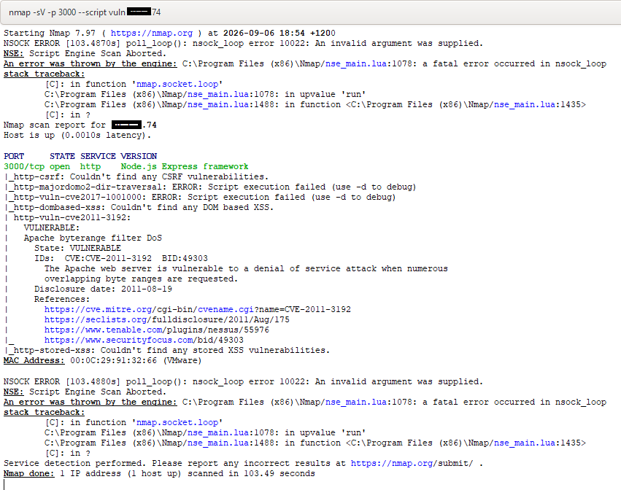

Pair with WireShark for further analysis?

This report took me about 1 hour (including scanning time) (I’ll be honest I didn’t quite know what to write so most of it was me scratching my head).

